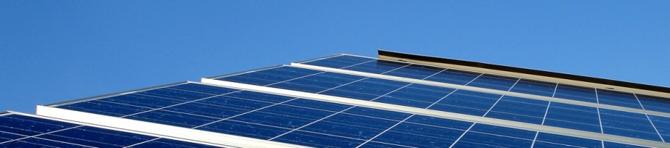
Sponsored by the Citi Foundation, The Greater Fort Lauderdale/Broward Economic Development Alliance, Broward College, the Broward College Foundation, and Workforce One
The Broward County Green Workforce Innovation Project
White Paper, Second Draft

Timothy McWhirter, Ph. D., Program Director
Valerie J. Amor, LEED AP BD+C, AIA Assoc, Advisor
Greg Lindeblom, M. A., Advisor
Gino Galli, M. A., Advisor
04/19/2010
www.greenworkforce.wordpress.com

Table of Contents

INTRODUCTION…..…………………………………………………………………………………………….2
ENERGY EFFICIENCY………….…………………………………………………….………………………..5
Broward County Minority Builder’s Coalition …………………………………..….5
PACE Financing ………………………………………………….……………………………….. 7
SOLAR TECHNOLOGY……..………………………………………………………………………………. 13
Advanced Green Technologies, Inc.………………………………………………..….. 13
BIOMASS……………………………………………………………………...………………..……………….18
Wheelabrator Technologies, Inc.………..………………………………………….,…. 20
RESEARCH INTO THE FUTURE…………………………………………………………………………. 23
CONCLUSION………………………………………………………………………………………………….. 24
REFERENCES……………………………………………………………………………………………………. 26
GREEN WORKFORCE THINK TANK….………………………………………………………………. 26
SPONSORS……………………………………………………………………………………………………… 27

Introduction
The Broward County Green Workforce Innovation Project (GWIP) was created from a unique partnership between the Greater Fort Lauderdale/Broward Economic Development Alliance, Citi, and Workforce One. These organizations came together to form the Green Workforce Think Tank. Since March 2009, this think tank has been meeting regularly to share information and collaborate on initiatives that encourage the development of a green economy in Broward County. In June 2009, the Citi Foundation awarded a $50,000 grant to Broward College for the purpose of creating the GWIP.
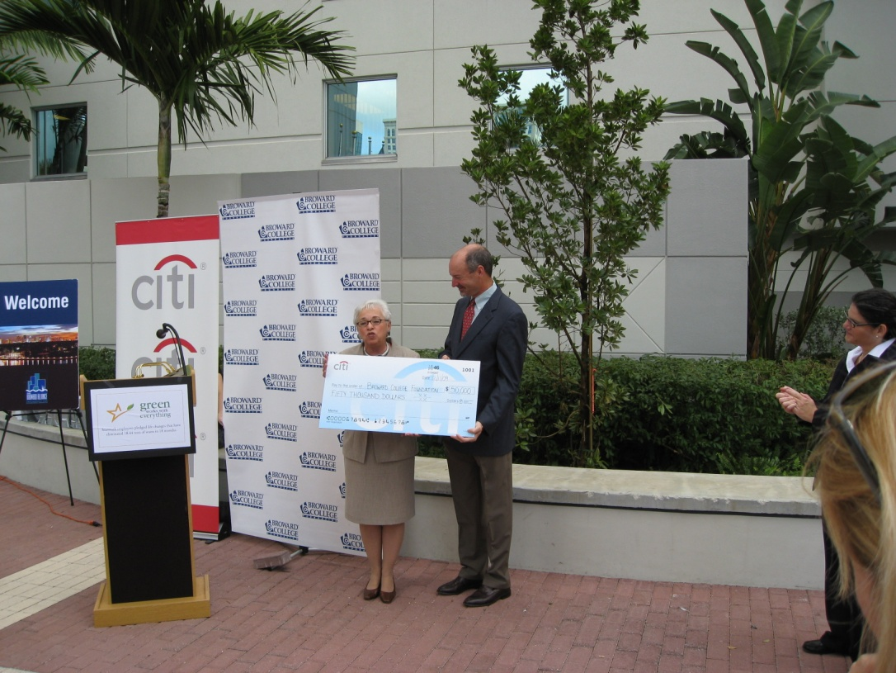
Barbra Romani, Citi Director of Community Relations, and
J. David Armstrong Jr., President of Broward College
The primary goal of the GWIP is to conduct a study that will inform the development of a green economy in Broward County. We seek to do this by, first, investigating where the green jobs are likely to emerge. Second, we explore whether there may be opportunities to provide job training in key areas that will help the growth of green jobs. Third, we investigate whether there are possible changes in public policy that could encourage the growth of a green economy. This white paper summarizes the findings of the GWIP.
The target audience for this study includes business and industry leaders, legislators, and other government officials. The recommendations are developed with this audience in mind and are intended to provide realistic, viable and timely options for encouraging the growth of a green economy.
Before proceeding any further, we should define more specifically what we mean by “green jobs” and a “green economy.” There are a number of different definitions that have been used. The most comprehensive definition discovered in our research is provided by a report commissioned by the PEW Charitable Trusts, The Clean Energy Economy. This report describes green jobs, or what it calls “clean jobs,” as being those associated with:
(1) Clean Energy; (2) Energy Efficiency; (3) Environmentally Friendly Production; (4) Conservation and Pollution Mitigation; and (5) Training and Support (p. 5).
A Solar thermal system designer and installer would be an example of a job associated with clean energy. A construction worker who weatherizes homes would be an example of a job associated with energy efficiency. A sustainability director would be an example of a job associated with conservation and pollution mitigation. Those trainers and educators that prepare people for all the jobs above would be examples of jobs associated with training and support.
Our research on the GWIP was influenced by the Broward County Targeted Industries Study. In April of 2008, the Broward County Department of Economic Development commissioned DCG Corplan Consulting LLC, a nationally-renowned economic development consulting and site selection firm, to undertake a year-long investigation of the County’s economy. From 2000 to 2005, some of the strongest growth was concentrated among the county’s lowest paying industries, e.g., accommodation and food service, retail trade, and educational services. The Targeted Industries Study was commissioned to reverse this trend and encourage the development of high skill/high wage jobs.
The Targeted Industries Study provides a unique picture of the Broward County economy that helps us understand where we can anticipate growth. Among these areas likely to grow, we can further distinguish those that are green. This is one of the methods we used to distinguish the three sectors of the Broward economy in which green jobs are most likely to emerge: Energy Efficiency, Solar Technology, and Biomass.
Within each sector we identified a large, well established company which became the basis of Broward-specific case studies. These case studies focus on three primary areas:
- Developing a general understanding of the business;
- Exploring whether there may be opportunities to develop training programs that could enhance the growth of the business;
- Looking for opportunities to enhance the growth of the business through changes in public policy.
The case studies and the reports we consulted are used to support recommendations for how to encourage the growth of a green economy in Broward County.
The January 2009 GreenForce Florida report commissioned by the Florida Department of Education states that:
Green-collar job workforce efforts should be linked, whenever possible, to existing policies, programs and investments aimed at growing the green economy and combating climate change. For example, a city might require that green businesses that benefit from municipal tax credits or other incentives participate in green-collar job training partnerships, allocate funds to on-the-job training for current workers transitioning to the new energy economy, or hire workers from a Green Jobs Corps or similar program (pg. 20).
There is a clear need to focus on exploring financing and incentive programs that could be linked with job training programs to foster the growth of a green economy. Financing and incentive programs can increase demand for green technologies and increase the probability that those who receive training for a green job will be able to find one. Training programs can insure businesses can find qualified employees as they grow.

Energy Efficiency
Increasing efficiency of buildings and equipment
Growth trend in 2009
Over $4 million in training grants
PACE financing will help
Minority Builders Coalition a state leader
While the job market may be bleak, companies focused on energy efficiency around the world are proudly proclaiming “now hiring” according to the 2009 Clean Energy Trends report by Clean Edge, a clean energy research firm. They are hiring workers to weatherize buildings and produce, manufacture and install energy efficient equipment and materials. This trend is driven by stimulus dollars and a “growing realization by companies, utilities, and governments that volatile energy costs make energy efficiency a highly competitive option for meeting their new energy needs, and a cost-effective job creator” (pg. 10).
Energy efficiency is actually an important part of many jobs. When, for example, an accountant develops an ability to work in a paperless fashion, she can increase the energy efficiency of her work. There is, therefore, a sense in which all jobs are becoming greener. In our research, however, we focused on those jobs that we might say are exclusively green as described by the five areas outlined above in the definition from the PEW report.
A Leading provider of weatherization services in FL
70 Contractors
Began in 1973
$3.2 million grant

The Broward County Minority Builders Coalition
The Broward County Minority Builders Coalition (BCMBC) is one of the largest providers of weatherization services in the state of Florida. It represents a coalition of 70 contractors across the state and has been in operation since 1973.
In 2009, the Broward County Minority Builder’s Coalition received a $3.2 million grant and the Opportunities Industrialization Center (OIC) of Broward County received $1 million of a grant. These two grants together total over $4 million dollars and they are for job training programs in the energy efficiency and renewable energy industries. The training and certification for these programs will be provided by the Broward Technical Centers and the OIC of Broward County.
The Broward Technical Centers have a long history in the county of providing effective job training programs. They have three locations: the Atlantic Technical Center in Coconut Creek; the McFatter Technical Center in Davie; and the Sheridan Technical Center in Hollywood.
The OIC of Broward County is an affiliate of the OIC of America. It carries out the mission of the OIC of America by providing employability skills training, basic computer skills, case management and employment placement for welfare recipients and ex-offenders in Project Second Chance supported by the Broward County Work Force Development Board (WorkForce One) and the United Way of Broward County.
The $1 million of grant funds received by the OIC of Broward County are part of a “Pathways out of Poverty” grant from the federal stimulus package. The funds will support programs that serve a population that includes the unemployed, veterans, at-risk youth and individuals living in impoverished communities. Broward County Public Schools Technical Centers will receive $400,000 of the grant revenue to train Broward residents in basic weatherization and solar PV techniques and technology. This additional money will allow the Technical Centers to expand and improve the job training programs and facilities in place. These facilities will include dedicated classrooms, laboratories, Florida Solar Energy Center certified instructors, and state of the art, outdoor installation training systems and roofs.
Together, these educational programs run by the Broward Technical Centers and the OIC of Broward County will represent the largest county oriented “green” workforce training effort in the nation. The BCMBC will use its coalition of contractors to provide industry career paths for 280 weatherization technicians.
In the grant project run by the BCMBC basic skills training will be provided by the OIC of Broward County and Broward Technical Centers (BTC). The OIC of Broward County will provide more flexible instruction once employed; BTC will provide instruction concurrently during job skills training. These programs will offer roughly four times the amount of hands on training as that typically provided by similar classes. The program's graduates will be eligible for national certification and one of the hundreds of jobs already committed by program partners. The table below outlines all the jobs that are scheduled to be provided by BCMBC and the Broward Alliance for Neighborhood Development as a part of the project.
OCCUPATION | Current Employment | BCMBC* |  | BAND* |  | Total Est. Hiring Needs | Total Commit. for this Project | Average Salary
OCCUPATION | Current Employment | Est. Hiring Needs | Commit. for this Project | Est.  Hiring Needs | Commit for this Project | Total Est. Hiring Needs | Total Commit. for this Project | Average Salary
Weatherization Technicians and Installers | 800 | 575 | 280 | 45 | 20 | 620 | 300 | $30,000
[*BCMBC, Broward County Minority Business Coalition; BAND, Broward Alliance for Neighborhood Development]

PACE Financing
There are a number of innovative financing programs being used around the country. Some are provided by financial institutions and do not require government intervention. Energy Efficiency mortgages are a good example. They provide homeowners and buyers financing for energy efficiency purchases and retrofits. Government and community groups can assist these programs by helping advertise them to the public.
Other programs are sponsored by local governments. After exploring a number of innovative government sponsored programs used around the country, one distinguished itself in terms of its effectiveness and political viability: PACE financing.
PACE financing refers to Property Assessed Clean Energy financing. These unique programs began in California and have rapidly spread across the country. On March 17th 2010, PACE legislation passed the Florida House Energy & Utilities Policy Committee and the Senate.
PACE programs allow homeowners and small businesses to finance energy efficiency retrofits and renewable energy installations through their municipality or special district. They can amortize expenses over 20 years and pay them back through supplements to their property taxes. If a customer chooses to move, the financing stays with the home along with the technology. PACE programs allow homeowners and small businesses to move to renewable energy without any upfront costs. Because of the long term financing, many energy efficiency retrofits will actually make the customer cash positive day one: the amount of money they save on energy costs will exceed their loan payments. These programs are therefore extremely popular. In Sonoma County California, their PACE program increased construction the first year by 8.4%. The Harvard Business Review described PACE financing as one of the 10 Breakthrough ideas for 2010 (January 2010).
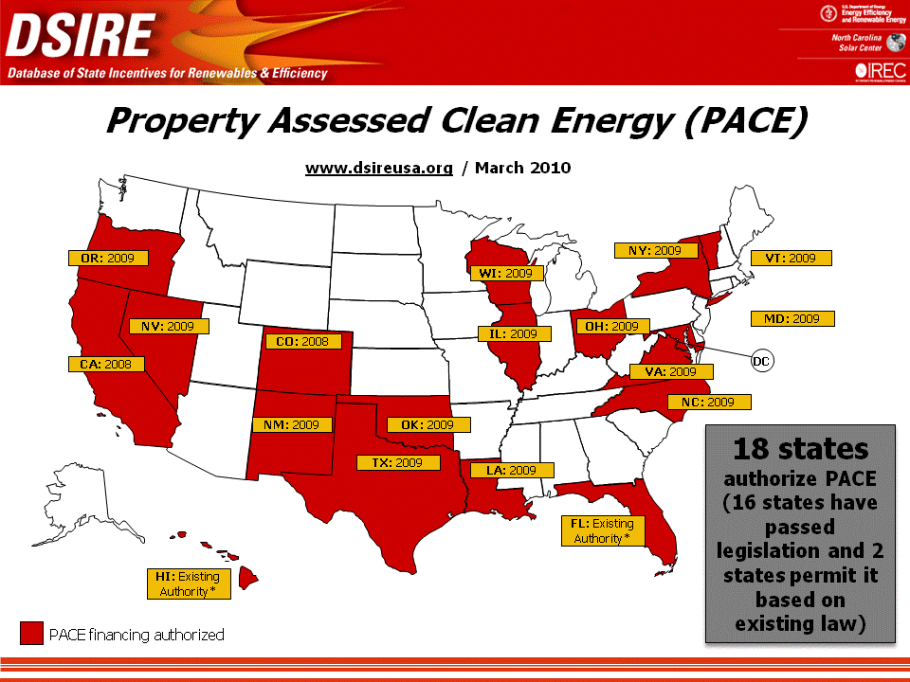
Perhaps the only thing more remarkable than the success of these PACE programs is the political support they enjoy during a period of heightened disagreement and divisiveness. In what New York Legislators called an “extraordinary” session, lawmakers voted to authorize PACE legislation by a vote of 192 – 0. There was not one single no vote. In October of 2009, Vice President Biden released Policy Framework Guidelines for PACE programs in an effort to encourage their use (http://www.whitehouse.gov/assets/documents/PACE_Principles.pdf). Indian River County, Florida Commissioner Peter O’Bryan proposed a PACE program for his county in February. Broward County Commissioner Kristen Jacobs said in February 2010 that the county was interested in researching PACE programs, particularly the model used in Sonoma, California. Evaluating PACE financing programs is one of the priority recommendations in the Broward County Climate Change Action Plan, released May 4, 2010.
The Sonoma model is particularly interesting for Broward County. The PACE program in Sonoma works in conjunction with a job training program run by the North Bay Institute of Green Technology called Youth Green Jobs Sonoma. This program takes in at-risk youth with barriers to employment and provides them training for energy efficiency jobs. The training is provided using local contractors. The PACE financing program therefore not only benefits these contractors but it also benefits the troubled youth that are trained by them.
“Evaluating a bond-funded renewable finance district program”
Action MI-2.1
Broward County Climate Change Action Plan
May , 2010
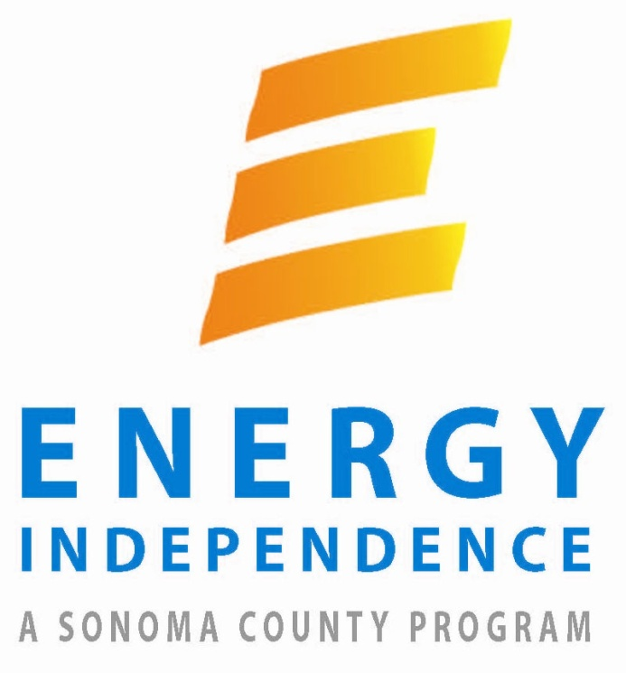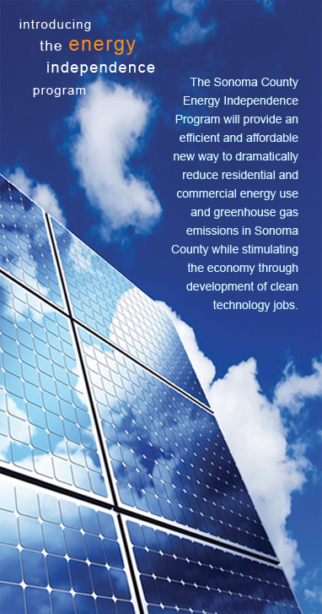
In Broward County we have the opportunity to replicate a similar set of programs, given the aforementioned grants received by the Broward County Minority Builders Coalition and the OIC of Broward County.
The public policy recommendations of this report for the energy efficiency sector concern PACE financing. First, the county should begin to research PACE programs across the country to learn the best practices to incorporate here. This is one of the primary recommendations of the recently drafted (May 10, 2010) Broward County Climate Change Action Plan (Action MI-2.1 pg. 41). The Green Workforce Think Tank is uniquely suited for this task because of the broad coalition it represents, its connections to the County Commission, its focus on economic development, and its association with the local institutions of higher education.
Second, plans should be made to coordinate the county’s PACE program with the existing job training programs. The Green Workforce Think Tank is also uniquely suited to serve as the body which coordinates these programs for all the reasons cited above and because most of the members of the job training programs are already in the Think Tank. These programs should be coordinated in terms of timing. If a PACE program is in place by the time the first trainees finish their training, it will increase the probability they will find jobs.
These programs should also be coordinated through advertising. Consumer market research done recently by the organization SmartPower reveals that 62% of respondents in Arizona said they heard about their utility company’s solar rebate from their installer. Only 24% said they heard about the rebate through their utility company. Contractors are often used to communicate and advertise financing and rebate initiatives to customers. The contractors involved in the county’s job training grant projects can be used to communicate and advertise the county’s PACE program to customers, as well as other financing programs available, like energy efficiency mortgages.
Coordinating these programs in this way will make both more effective. If the county only implements a job training program, it increases the chances people will be trained for a spot on the unemployment line. These chances have already increased dramatically because the state’s rebate program has not been funded. If the county only implements a PACE financing program, it could cause a growth in the industry that out paces the ability of contractors to train qualified employees. This would place a downward pressure on quality and an upward pressure on prices. If the county coordinates a PACE financing program with the job training programs already in place it can foster the growth of a green economy in a responsible manner that avoids these two potential problems.
Third, Broward County should consider using public investments to fund its PACE program. In Sonoma the County Treasurer moved a small percentage of the county’s public investments into PACE bonds in order to generate the revenue for their PACE program. Right now colleges and universities are graded on their sustainability initiatives, including their investments, by the College Sustainability Report Card and other organizations. Institutions that invest in sustainable investments, like PACE bonds, are graded higher than institutions that do not. Consequently, if Broward County were to use Sonoma’s approach to generating revenue it would increase the sustainability of the county’s educational institution’s investments while generating revenue for the PACE program.
Fourth, the PACE program should not be run as a pilot that comes to an end; it should be run with the intention of scaling up the revenue involved until a plateau is reached and sustained. This will responsibly foster the growth of a green economy. The program provides citizens the same kind of long term municipal financing public utilities have always enjoyed. It should be conceived as an ongoing public service.
Fifth, as a consequence of this last point, the county should work with the private bond market to make sure it can seek private funding for the program when and if necessary. Private bond holders may, for example, be more comfortable if PACE loan payments are made monthly rather than annually. If changes are made at the outset to these PACE bonds that make them more attractive to private bond holders, it will provide the county more options in the future when considering the best way to fund the program as an ongoing service.
Sixth, information from the participants in the PACE program should be used to achieve a number of objectives: A) improve consumer decisions by providing information about the performance of technology in real world situations, B) help insure quality control in the program by making sure revenue is not wasted on projects that provide less benefit, C) help highlight the benefits of the program, D) support research projects.
Seventh, Broward County should consider working with local counties to form a PACE program. The state recommends grouping local bond programs together to get better rates. Broward County has a tradition of working together with neighboring counties on climate change initiatives and is in the process of developing a regional collaborative climate action plan. Broward County should strongly consider leveraging this tradition of cooperation to develop a regional PACE program that provides better rates.
Energy Efficiency Recommendations
- The Green Workforce Think Tank should research best practices for PACE programs.
- The PACE financing program that is implemented should be coordinated with the existing job training programs in the county.
- Broward County should consider using its public investments to finance a PACE financing program.
- The PACE program should be considered an ongoing public service.
- The private bond market should be included in the PACE program.
- Information from the program should be used to improve consumer decisions, insure quality control, highlight benefits of program, and conduct research.
- Broward County should consider working with neighboring counties to form a regional PACE program that provides lower rates.

Solar Technology
Using sun to create energy.
Great potential for south Florida.
Prices dropping in 2010.
Advanced Green Technologies, Inc.
The Targeted Industries Study describes businesses associated with photovoltaic technology as being “prevalent” and having “great potential for the south Florida market area” (pg. 15). This year’s Clean Energy report by Clean Edge describes photovoltaic prices dropping substantially. Two primary reasons are cited. First, thin film solar panels have been brought to market. They are much less expensive but they are also much less efficient. Second, silicon prices are finally returning to their traditional levels after soaring as a result of increased demand.
The Targeted Industry Study describes the establishment of a Photovoltaic assembly facility in Broward County as being likely to “encourage development of a cluster of suppliers, designers, researchers, and installers” (pg. 15). Broward County is presently in discussions with a number of solar technology manufacturers who are considering locating in the county, including Off Grid Solar. This company is in a partnership with a solar technology installation training company called the U. S. Solar Institute and a solar technology installation company called Florida Solar One, Inc.
The Broward County Commission is planning to move county buildings to renewable energy where it is “economically feasible” to do so. As mentioned, the County Commission is also interested in implementing a PACE financing program that will make it easier for homeowners and small businesses to afford renewable energy installations. Solar technology does appear to have “great potential” in Broward County.

Advanced Green Technologies, Inc.
There are many companies presently operating in Broward County that install solar technology. One of the industry leaders is Advanced Green Technologies, Inc. (AGT). AGT has focused on the use of thin film solar cells, among other technologies.

Spin off from Advanced Roofing
Trains roofers to install solar
Part of training grant
www.agt.com
Thin Film Solar Cells
Advanced Green Technologies, Inc. (AGT) spun off from Advanced Roofing, Inc. in 2007 and has a close affiliation with roofing companies around the country. AGT focuses on providing roofing companies the training they need to install renewable energy technology. This training is provided both on-site and in-class. Because of its partnerships with roofing companies across the country¸ AGT has developed an expansive market for delivering renewable energy technology.
AGT is a participating partner in the Broward County Minority Builders Coalition grant project. They plan to use their network of roofing companies to provide career paths for 200 trainees over the course of the project. The following chart illustrates how AGT along with the International Brotherhood of Electrical Workers (IBEW) are scheduled to place a number of trainees in jobs.
OCCUPATION | Current Employment | AGT* |  | IBEW* |  | Total Est. Hiring Needs | Total Commit for this Project | Average Annual Salary
OCCUPATION | Current Employment | Est. Hiring Needs | Commit  for this Project | Est.  Hiring Needs | Commit  for this Project | Total Est. Hiring Needs | Total Commit for this Project | Average Annual Salary
Solar Thermal System Designer and Installer | 350 | 80 | 50 |  |  | 80 | 50 | $46,000
Solar PV System Designer and Installer – Skilled | 778 | 75 | 20 | 225 | 30 | 300 | 50 | $48,000
Solar PV System Installer – Entry Level | 545 | 300 | 130 | 100 | 95 | 400 | 225 | $41,000
TOTALS |  | 455 | 200 | 325 | 150 | 1,400 | 700
[*AGT, Advanced Green Technologies, Inc.; IBEW, International Brotherhood Electric Workers]
These projections are however based on the assumption that the State’s rebate program for renewable energy technology is funded. Unfortunately, the rebate program has not been funded and this undermines the ability of contractors to meet their job placement targets.
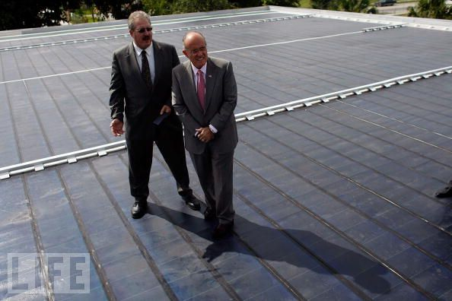
Rob Kornahrens, President of Advanced Roofing, Inc., and former New York Mayor Rudolph Giuliani
Rob Kornahrens, president of Advanced Roofing, Inc., writes in the SunSentinel on April 28th, 2010 that unless there is new legislation that increases demand for solar technology the training in the BCMBC grant program “may go to waste or the newly trained Floridian will have to move to find a job in renewable energy.” Kornahrens supports a recent house bill, HB 7229, that, among other things, makes it easier for public utilities to recover from customers the cost for renewable energy projects. This bill, Kornahrens argues, will increase the demand for utility scale solar technology manufacturing in the state, which will reduce the cost of solar technology and increase the generation of green jobs.
The PACE programs that are spreading across the country have increased demand for solar technology. These programs take away the need for a large upfront investment. They also provide customers the freedom to sell their home and have the new owner take over the payments for the installation.
When PACE programs are used to finance energy efficiency retrofits and solar thermal installations, often the money saved on energy costs will exceed the PACE loan payments: so customers are cash positive day one. The installation actually saves them money. This, however, is not always the case when PACE loans are used to finance photovoltaic technology installations, particularly in Florida where the price of electricity is relatively low. PACE financing will not necessarily make Floridians cash positive day one for PV installations. This is one of the reasons why the prospects for solar thermal technology in the county are considered by some to be better than those for solar PV.
There is, however, more that can be done, particularly in Florida, to reduce the cost of PV installations. In Denver, for example, a group called Partnership for Sustainability has created a revolving loan fund that is supported by donations. This fund is used to provide residents and small businesses interest free loans to finance PV installations. As the revenue is repaid, it is loaned out again to finance more installations—the revenue is, in this sense, renewable.
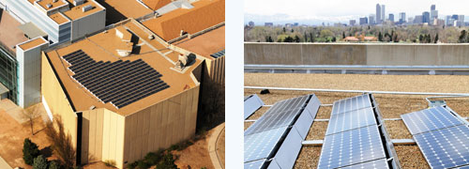
Denver Museum of Nature and Science installation financed by Partnership for Sustainability
Floridians have made it quite clear they are willing to support the development of solar energy. This can be seen, for example, in the short lived Florida Power and Light (FPL) Sunshine Energy Program. FPL asked its customers to voluntarily donate $9.75 a month to support the development of solar energy in the state. 39,000 customers stepped up to the plate and provided the company almost $3 million a year for four years. The total received by the company over the four years was $11.4 million. The Florida Public Service Commission did a report on the program and found that 75%-80% of the funds were used for administrative and marketing costs. Consequently, they closed the program (June 29th, 2008 news release).
The willingness of Floridians to support solar energy is further demonstrated in a recent Mason-Dixon poll which showed that 80% of Floridians say they are willing to pay up to $1 a month to support solar energy (reported in “Florida Groups Support New US $114M Renewables Fund” in RenewableEnergyWorld.com, February 23, 2009). Until this support is used in a responsible manner to reduce the cost of financing for solar energy installations, we simply have not reduced the cost of solar energy in Florida to the extent that we can.
The Broward County Climate Change Action Plan recommends that a voluntary check box be placed on property tax bills and other billing instruments in order to generate funds for renewable energy projects (Action MI-2.2, pg. 41). The public policy recommendation of this report for the solar technology sector is that Broward County should consider developing a revolving loan fund for solar PV installations that is supported by donations. North Carolina has passed legislation that allows local governments to create revolving loan funds for renewable energy technologies. These programs can provide interest free loans. This fund should be set up so that it can be implemented through the County’s PACE program, providing customers all the benefits of the PACE approach. This revolving loan component of the PACE program can help further reduce the cost of PV installations for Broward County residents and businesses.
Solar Technology Recommendation
- Broward County should consider developing a revolving loan fund for solar PV installations that is implemented through a PACE program.

Biomass
The first green industry that is described by the Targeted Industry Study as being “essential to preserve (the) state’s status in the innovation economy” is the production of alternative energy from biomass. Southern Florida has a long growing season and a number of citrus and sugarcane farms. This strength is reflected in two reports done by PEW Center on Global Climate Change.
Using agricultural and municipal waste to create energy.
Essential to innovative economy
Expansion a trend 2010
State and County plan to increase use.
Wheelabrator Technologies Inc. operates two plants in County.
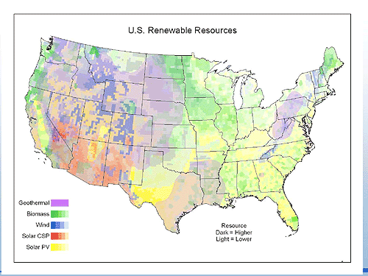
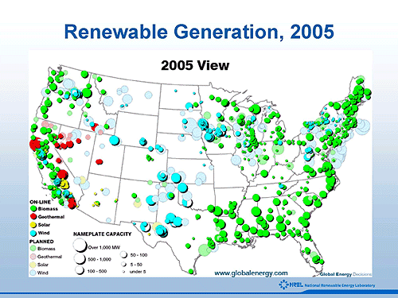
Source: Pew Center on Global Climate Change
Clean Edge writes in their 2010 Clean Energy Trends report that “FirstEnergy, Southern Co., Excel Energy, and many other utilities have recently converted or are planning to fully or partially convert their coal and natural gas boilers to biomass (known as ‘repowering’)”(pg. 12). This report goes on to say that the U. S. Department of Energy and Agriculture estimates that U. S. biopower:
can sustainably reach five percent of the nation’s industrial and electric generator energy demand by 2020 by utilizing existing waste streams and increased output from forest and agricultural land – without displacing food production or impacting environmentally sensitive areas. Some industry analysts have projected that the number could be far greater, with the potential for biomass to sustainably provide up to 20 percent of total U. S. electricity generation (pg. 13).
The production of energy from biomass does raise some concerns. Critics point out that it releases particulates and other pollutants and they question whether it really reduces CO2 emissions. Supporters argue that the emissions are far less than those from coal plants when we take into account new cleaner-burning boilers and the full biomass life cycle.
The Clean Edge report concludes that “regions like British Columbia and the American Southeast that have forestry infrastructure and knowhow are eyeing woody biomass use as a way to revive economic activity…. Despite its many challenges, woody biomass’s unique versatility and distinct advantage as a baseload power source make it an increasingly important piece of the energy puzzle”(pg. 13).

Wheelabrator Technologies, Inc.
Broward County has two waste-to-energy plants. Both are owned and operated by Wheelabrator Technologies Inc. The county and the state have plans to increase the amount of municipal waste that is sent to waste-to-energy plants.
In Broward since 1991.
Two plants in County
Over 100 employees
generates 134 megawatts
Enough for 77,000 homes
Operates 24 hours a day, 7 days a week.
www.wheelabratortechnologies.com
Wheelabrator Technologies, Inc. operates two waste-to-energy plants in Broward County: one in the north and one in the south. They are a wholly owned subsidiary of Waste Management and have been in operation since 1991. These plants take municipal waste and burn it at high temperatures to produce electricity. They use state-of-the-art technology to control emissions. The process reduces the amount of space used in the landfill by 90%.
Wheelabrator Technologies, Inc. operates 16 waste-to-energy facilities around the world. They have a collective solid waste disposal capacity of 21,340 tons per day, as much trash as that disposed of by more than nine million people.

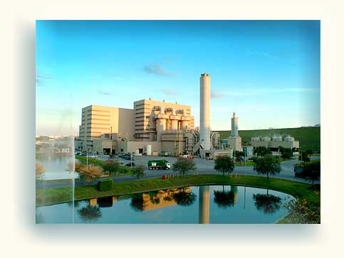
Wheelabrator Technologies, North Broward
Their Broward plants employ over 100 workers. On the training side, the managers of waste-to-energy plants will generally have advanced degrees in related fields of engineering. Most of the employees at these plants will however be technicians that do not have advanced degrees. The training required will vary from position to position. But there is a general body of knowledge that relates to the overall functioning of the plant that technicians will need to know. This information can often be provided through on the job training. But it can also be provided by outside institutions that have partnered with the plant to develop the appropriate curriculum.
While Wheelabrator employs over 100 employees in the county, each plant is so efficient it can be operated by just six employees. Both plants also operate at capacity. So if the state and county do increase the amount of waste they send to waste-to-energy plants, it will not increase the size of the workforce needed at these Wheelabrator plants. More plants will have to be created in order to meet this demand.
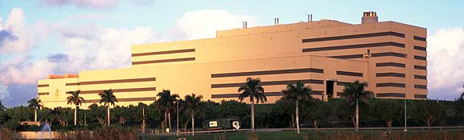
Wheelabrator Technologies, South Broward
As far as public policy is concerned, there are already big steps being taken to encourage the growth of the biomass industry in Broward County. Both the state and the county have plans to increase the amount of municipal waste that is sent to waste-to-energy plants. As renewable energy standards, mandates or goals are implemented across the country, the amount of waste sent to waste-to-energy plants around the country should increase. This will increase the demand for employees in the industry.
One recommendation of this report in the biomass area is that the county and state should increase the amount of waste sent to waste-to-energy plants in a responsible fashion. This increase should not be too large for the existing infrastructure to handle and it should not be temporary, which would merely force a reduction in capacity later. The increases should be calculated to foster the responsible growth of the industry.
PACE programs being developed in Vermont, Colorado, Nevada, Louisiana, and New York all include biomass technologies. The long-term financing provided by these programs can increase the profitability of small biofuel businesses and encourage the growth of more green jobs. The final public policy recommendation of this report for the biomass sector is that Broward County should follow the lead of these other states and include biomass technologies in its PACE program.
Biomass Recommendations
- State and county should increase waste sent to waste-to-energy plants in a responsible fashion.
- Biomass technologies should be included in the county PACE program.

Research into the Future
The picture below gives you a glimpse of one of the most promising energy sources for south Florida in the future: the Gulf Stream. Florida Atlantic University recently received a $1.2 million grant to do research on the performance of water turbines in the Gulf Stream.

The Gulf Stream
The sun and wind are both intermittent: they can be here one day and gone the next. The Gulf
Stream, on the other hand, provides a continual source of energy 24 hours a day, seven days a week, 365 days a year. FAU is testing the efficiency of water turbines and whether they will do any damage to underwater ecosystems.

Water Turbines

Conclusion
The evidence suggests that in Broward County green jobs are likely to emerge in: Energy Efficiency, Solar Technology, and Biomass. Within each of these areas there are a number of initiatives that can be taken to foster the growth of a green economy.
PACE financing clearly represents a promising tool. Implementing a program in the county should have a substantial impact, particularly working in conjunction with the job training programs already in place. These programs can work together to provide individuals in low to middle income communities a promising path to green jobs.
Energy Efficiency Recommendations
- The Green Workforce Think Tank should research best practices for PACE programs.
- The PACE financing program that is implemented should be coordinated with the existing job training programs in the county.
- Broward County should consider moving public investments into PACE bonds.
- The PACE program should be considered an ongoing public service.
- The private bond market should be included in the PACE program.
- Information from the program should be used to improve consumer decisions, insure quality control, highlight benefits of program, and conduct research.
- Broward County should consider working with neighboring counties to form a regional PACE program that provides lower rates.
Solar Technology Recommendations
- Broward County should consider developing a revolving loan fund for solar PV installations that is implemented through a PACE program.
Biomass Recommendations
- State and county should increase waste sent to waste-to-energy plants in a responsible fashion.
- Biomass technologies should be included in the county PACE program.

References
All of the reports and sources of information used in this white paper are listed on the project website at:
www.greenworkforce.wordpress.com/research/ www.greenworkforce.wordpress.com/pace/

Green Workforce Think Tank
This group assisted in the development and editing of this report:
Business
Joseph Beck Citi
Mark Chatten RWDI USA LLC
Debbie Danto Engineered Tax Services
Paul D'Arelli Berger Singerman
Paul Farren The Energy Store
Brian Johnson Broward County Minority Builders Coalition
Ray Johnson US Solar Institute
Tom Johnson RSM McGladrey
David Lewis Advanced Green Technologies
Ramon Rodriguez Citi
Vivian Schapsis Stylo Architecture, LLC
Marianne Winfield Marine and Waterways Solution
Education
Larry Calderon Nova Southeastern University
Ellyn Drotzer Broward College
Donat Forrest Broward College
Lynn Goldman Broward Technical
Jorge Guerra Broward College South Campus
Elissa Harvey Atlantic Technical Center and Technical High School
Tom Hindson Broward Technical
Kristin Holowicki Broward College
Deborah Hopkins Broward College
Mason Jackson WorkForce One
Marianna Jensen Atlantic Technical Center and Technical High School
Newton Sanon OIC of Broward
Carolyn Stewart Florida Atlantic University
Japp Vos Florida Atlantic University
Government/Non Profit
Scott Strawbridge Housing Authority of the City of Fort Lauderdale
Bob Swindell Greater Fort Lauderdale/Broward Economic Development Alliance
Joe Toliver United Way of Broward
Deborah Wilkinson Broward County OEDSBD
Samantha Zerbe Broward County OEDSBD
Ana Zeinieh The Broward Alliance

Sponsors
About Citi Foundation
The Citi Foundation is committed to the economic empowerment of individuals and families, particularly those in need, in the communities where we work so that they can improve their standard of living. Globally, the Citi Foundation targets its strategic giving on its priority focus areas: Microfinance and Microenterprise, Small and Growing Businesses, Education, and Financial Education and Asset Building. In the United States and Canada, the Citi Foundation also supports Community Development programs. The Citi Foundation works with its partners in Microfinance and Microenterprise, Small and Growing Businesses, and Community Development to support environmental programs and innovations. Additional information can be found at www.citifoundation.com.
About the Broward College Foundation
The mission of the Broward College Foundation is to change lives through education by providing community awareness, advocacy and financial support to Broward College. The Broward College Foundation awards more than $2 million in scholarships annually to Broward College students and supports academic programs and awards for outstanding faculty. While the State of Florida funds approximately 50 percent of Broward College’s operating budget, the balance must be raised from individuals, corporations and institutions. Led by its Board of Directors, the foundation raises funds, conducts programs and practices stewardship that increases the effectiveness of the college in meeting community, student, faculty and staff needs. For more information or to contribute to the Foundation, please call 954-201-7414 or visit www.broward.edu/foundation.

About Broward College
The mission of Broward College is to achieve student success by developing informed and creative students capable of contributing to a knowledge- and service-based global society. As a public community college accredited to offer associate degrees, selected baccalaureate degrees, and certificate programs, the institution and its District Board of Trustees are committed to fostering a learning-centered community that celebrates diversity and inclusion by empowering and engaging students, faculty, and staff. For more information please visit www.broward.edu.
About The Greater Fort Lauderdale/Broward Economic Development Alliance
Broward County’s official public/private partnership for economic development. Its mission is to build a stronger and more diverse economy by stimulating the creation of new jobs and capital investment while facilitating the growth and retention of businesses in Broward County. Services offered by The Alliance include assistance with business relocation or expansion and site selection; incentive programs and information; market research; small, minority- and women-owned business assistance; film permitting, government liaison and community resource referrals for film and television; and serving as a liaison for workforce development between educational institutions and the business community. To learn more, call (954) 524-3113 or visit www.browardalliance.org.
About WorkForce One
WorkForce One provides numerous employment-related services to businesses and individuals through three main centers and multiple satellite offices located throughout Broward County. Business services include employee training dollars, recruitment and placement assistance, screening and testing applicants and providing information on various financial incentives. Individual assistance includes access to the largest Internet jobs board, job placement services, career coaching and access to full-service resource centers for employment-related needs. For more information about WorkForce One services, visit www.wf1broward.com.

